DLTK's Crafts for Kids  Egg Carton Caterpillar  I have a bad habit of neglecting to do the old standards with my girls... I always want to do something 'new and exciting' with them. I forget that when you're in preschool, everything is new and exciting. Kaitlyn LOVED this craft -- I guess that's why it's an old standard. | 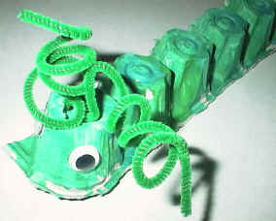

Materials:
- cardboard egg carton
- scissors
- green tempra paint
- paint brush
- pipe cleaner (chenille)
- sharp pencil
- wiggly eyes, 2 cheerios or 2 fruit loops
- glue

Instructions:
- cut one strip of cups (6 cups) from the egg carton -- adults can do this before craft time.
- paint the cups green and let dry
- using a sharp pencil, poke two holes in the top of the first cup -- again, adults should do this step.
- from inside the cup, poke both ends of the pipe cleaner through the pencil holes (one end through each hole)
- wrap the ends of the pipe cleaner around the pencil to make it curly
- glue the wiggly eyes onto the head (you could substitute 2 cheerios or 2 fruit loops)

